Digital Certificate
# Source: AI Source: Provided by: [Data Path: Persons Table -> ID Column: 1, Name_En Column: Motasem Essam] -> From: [ChatGPT] on [1/18/2026]
A digital certificate is an electronic document that proves the identity of a person, device, website, or service and links that identity to a public cryptographic key. It’s a core building block of secure communication on the internet.

🪪 What a Digital Certificate Is
# Source: AI Source: Provided by: [Data Path: Persons Table -> ID Column: 1, Name_En Column: Motasem Essam] -> From: [ChatGPT] on [1/18/2026]
Think of it like a digital ID card:
- Who you are → name, domain, organization, or device
- Your public key → used for encryption or signature verification
- Who vouches for you → a trusted Certificate Authority (CA)
- How long it’s valid → start and expiration dates
- Proof it’s real → digital signature from the CA

📄 What’s Inside a Digital Certificate
# Source: AI Source: Provided by: [Data Path: Persons Table -> ID Column: 1, Name_En Column: Motasem Essam] -> From: [ChatGPT] on [1/18/2026]
Typical fields include:
- Subject (owner identity)
- Public Key
- Issuer (Certificate Authority)
- Serial Number
- Validity Period
- Signature Algorithm
- Digital Signature
Example (PEM format)
-----BEGIN CERTIFICATE-----
MIIDXTCCAkWgAwIBAgIJAK5eM+5...
-----END CERTIFICATE-----

🛠️ How It Works (Simple Flow)
# Source: AI Source: Provided by: [Data Path: Persons Table -> ID Column: 1, Name_En Column: Motasem Essam] -> From: [ChatGPT] on [1/18/2026]
- Owner generates a key pair (public + private key)
- Public key is included in a certificate request (CSR)
- Certificate Authority (CA) verifies the owner’s identity
- CA signs the certificate and issues it
- Others trust the certificate because they trust the CA
The private key is never shared.

📍 Where Digital Certificates Are Used
# Source: AI Source: Provided by: [Data Path: Persons Table -> ID Column: 1, Name_En Column: Motasem Essam] -> From: [ChatGPT] on [1/18/2026]
- HTTPS websites (SSL/TLS)
- Database & server authentication
- Email encryption & signing (S/MIME)
- VPNs
- Code signing
- Smart cards & hardware security keys

🔐 Why They’re Important
# Source: AI Source: Provided by: [Data Path: Persons Table -> ID Column: 1, Name_En Column: Motasem Essam] -> From: [ChatGPT] on [1/18/2026]
- Prevent impersonation
- Enable encrypted communication
- Build trust between systems
- Support passwordless authentication

🧠 Types of Digital Certificates
# Source: AI Source: Provided by: [Data Path: Persons Table -> ID Column: 1, Name_En Column: Motasem Essam] -> From: [ChatGPT] on [1/18/2026]
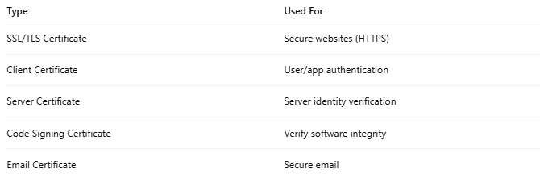
Type | Used For
SSL/TLS Certificate | Secure websites (HTTPS)
Client Certificate | User/app authentication
Server Certificate | Server identity verification
Code Signing Certificate | Verify software integrity
Email Certificate | Secure email

🔒 Key Security Notes
# Source: AI Source: Provided by: [Data Path: Persons Table -> ID Column: 1, Name_En Column: Motasem Essam] -> From: [ChatGPT] on [1/18/2026]
- Certificates expire and must be renewed
- Certificates can be revoked if compromised
- Private keys must be stored securely

🧠 Authentication Factor
# Source: AI Source: Provided by: [Data Path: Persons Table -> ID Column: 1, Name_En Column: Motasem Essam] -> From: [ChatGPT] on [1/18/2026]
- Something you have → certificate + private key

One-line summary
# Source: AI Source: Provided by: [Data Path: Persons Table -> ID Column: 1, Name_En Column: Motasem Essam] -> From: [ChatGPT] on [1/18/2026]
A digital certificate securely binds an identity to a public key, and is trusted because it’s signed by a Certificate Authority.

